<Login Page, Sign up, Sign up Page>

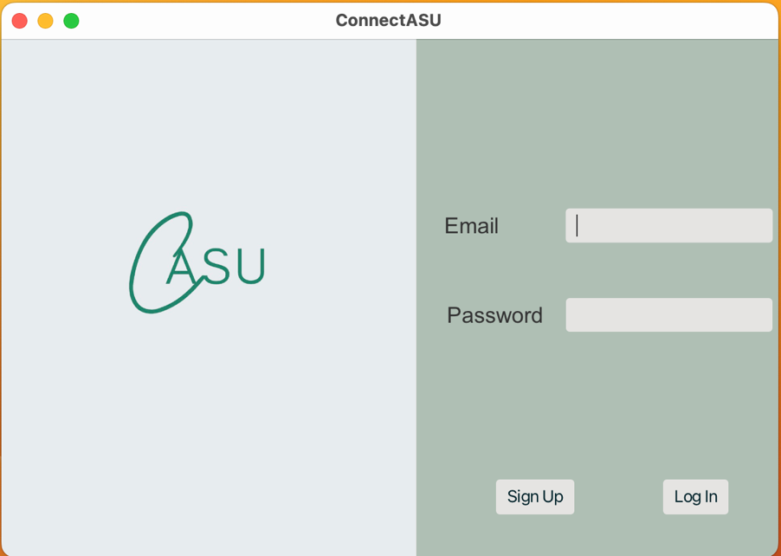

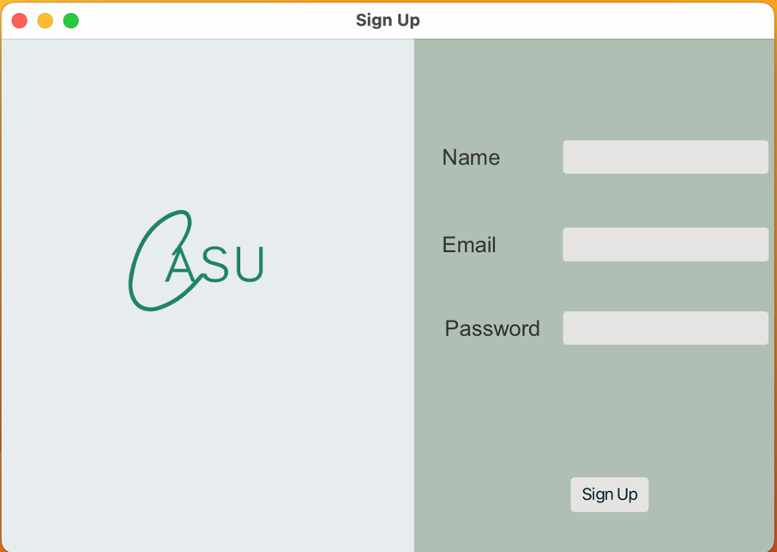

<Login Page, Valid Username and Passowrd , Feed Page >

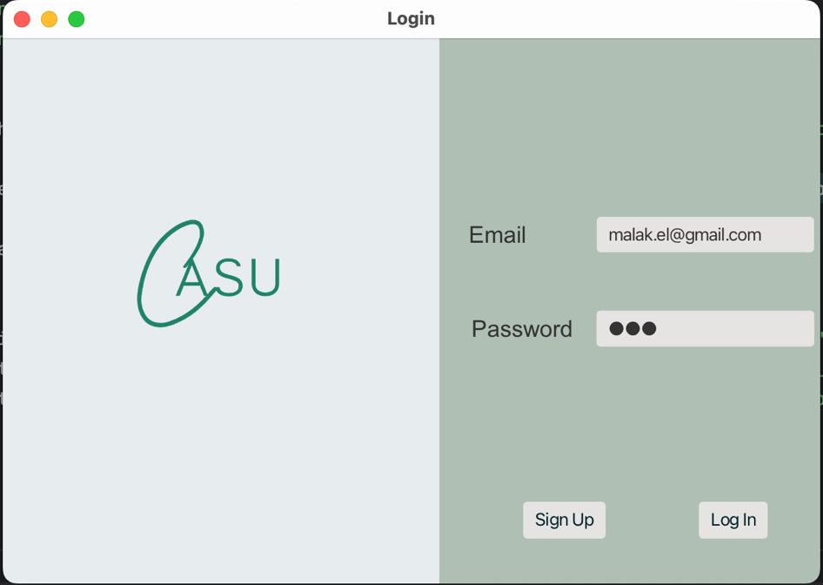

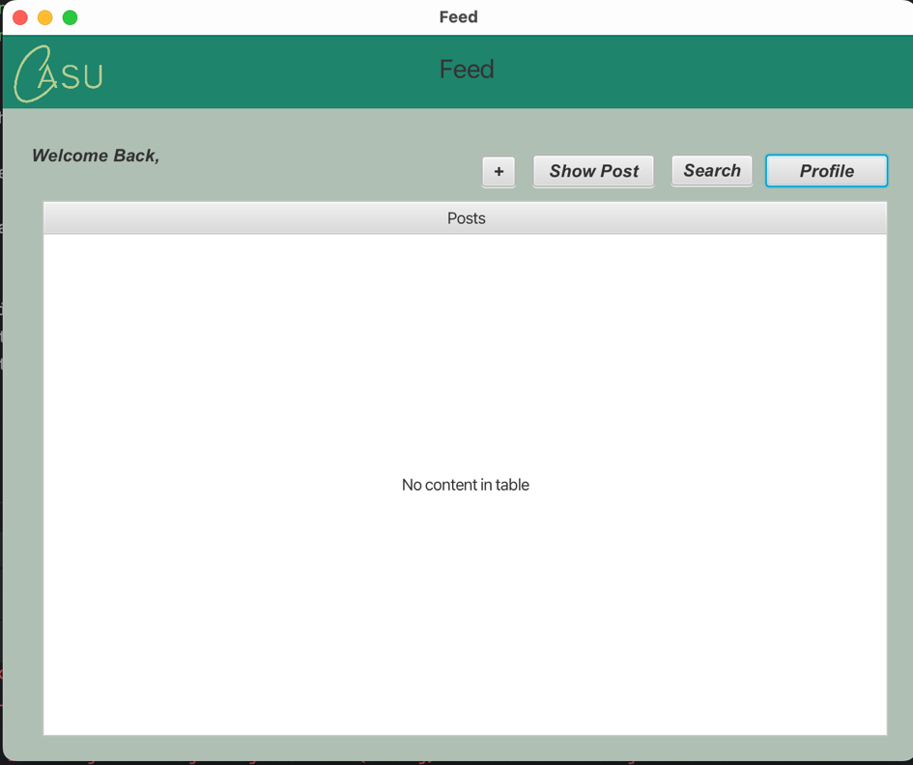

<Login Page, Invalid Email , Inavid Page , Back, Login Page>

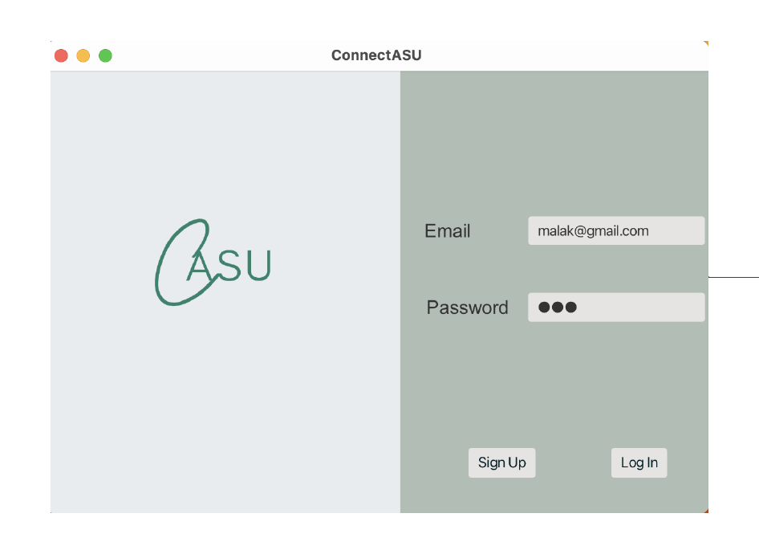

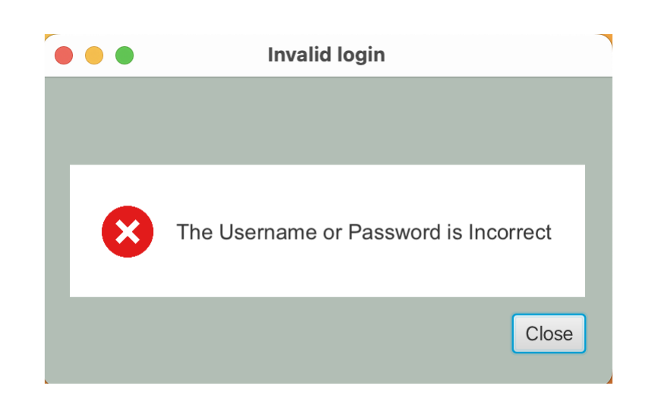

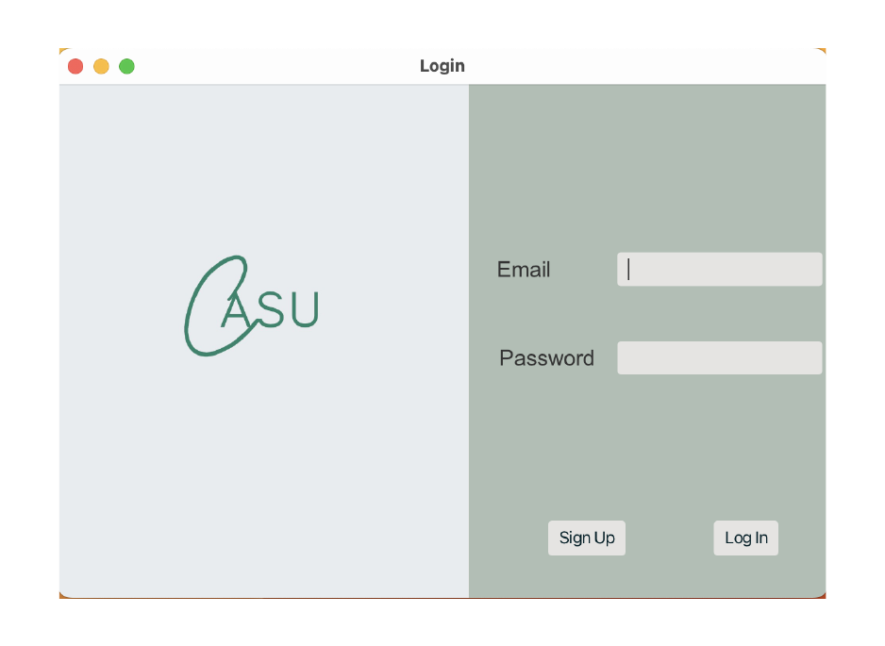

<Login Page, Invalid Password , Inavid Page , Back, Login Page>

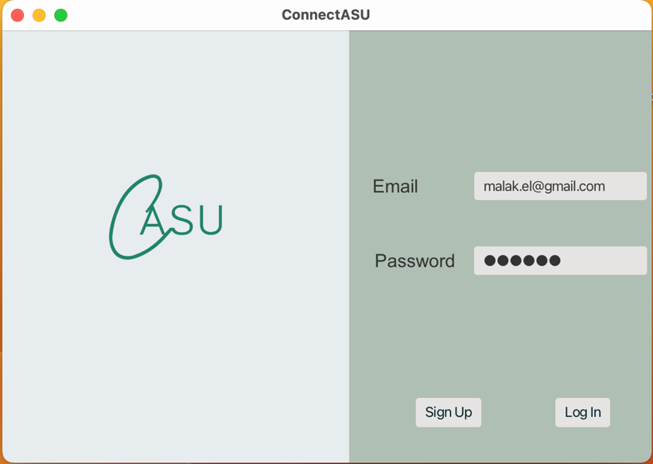





<Login Page, Empty Email , Inavid Page , Back, Login Page>

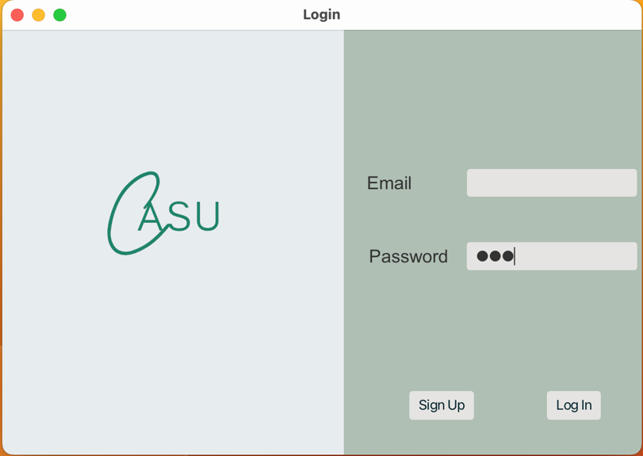





<Login Page, Empty Password , Inavid Page , Back, Login Page>

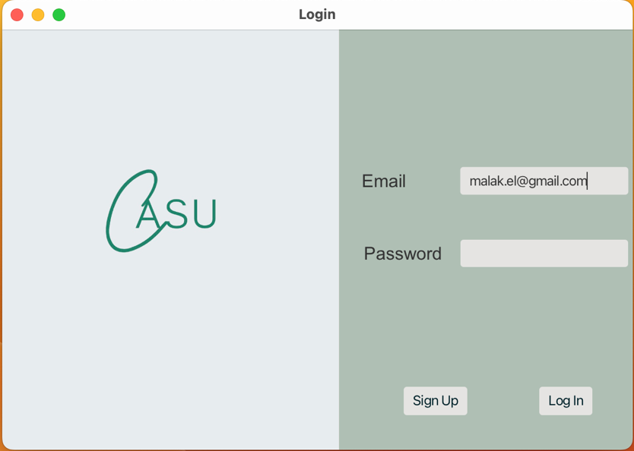





<Sign Up Page, Valid Email and Password and Non-Empty Name, Successful Page, Sign Up, Login Page>

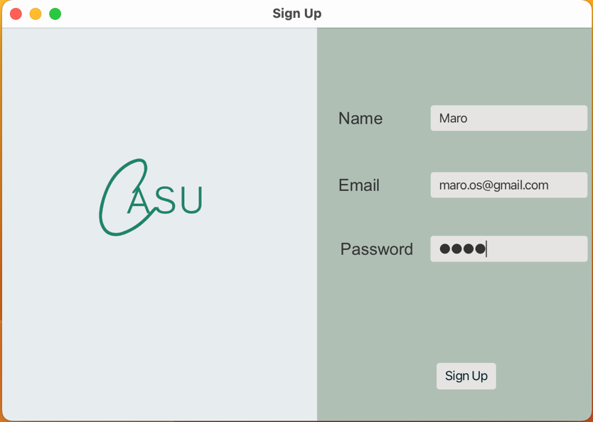

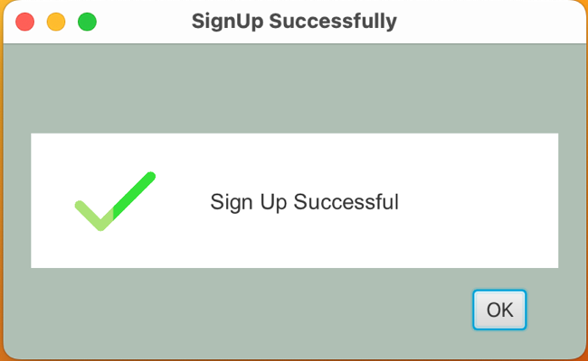



<Sign Up Page, Invalid Email, Invalid Sign Up Page, Back, Sign Up page>

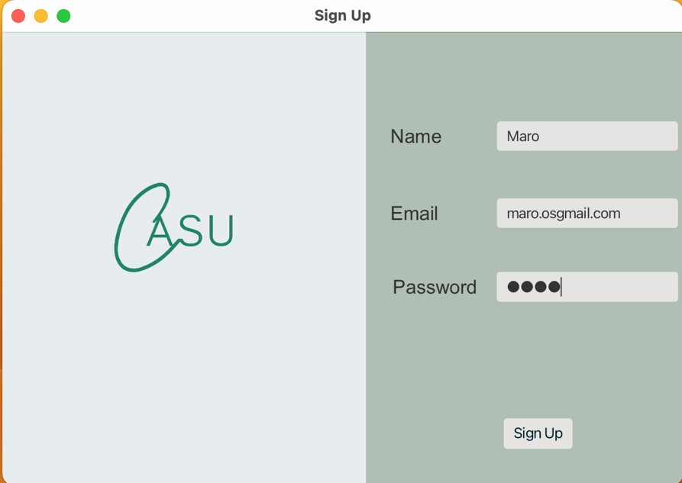

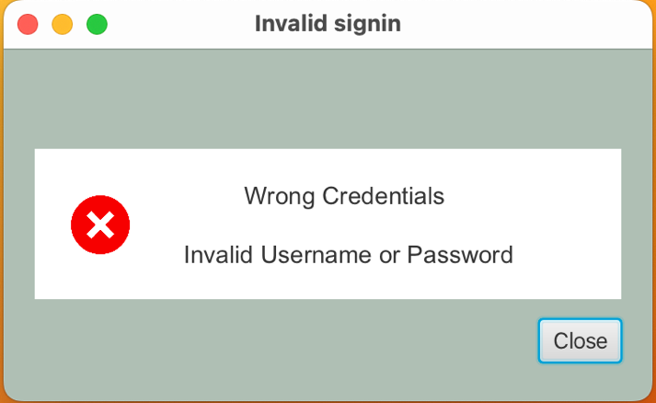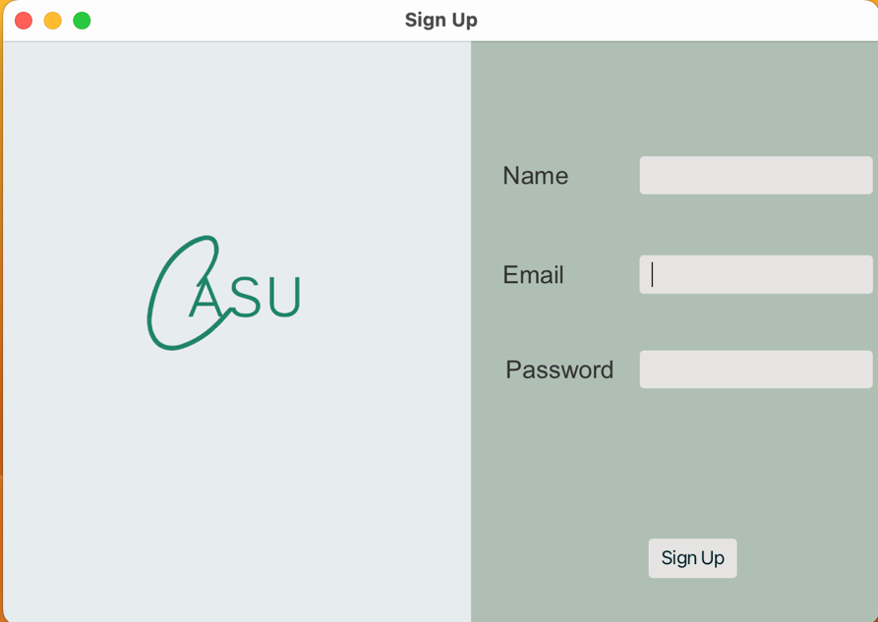

<Sign Up Page, Empty Name, Invalid Sign Up Page, Back, Sign Up page>

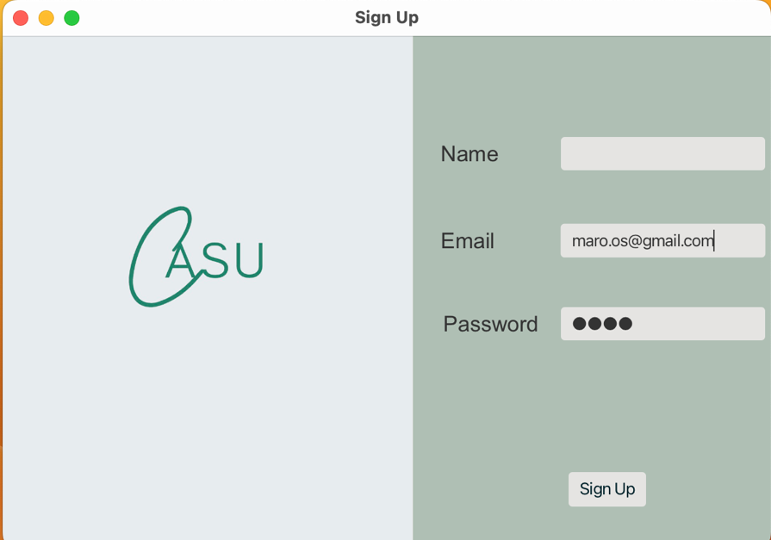





<Sign Up Page, Empty Email, Invalid Sign Up Page, Back, Sign Up page>

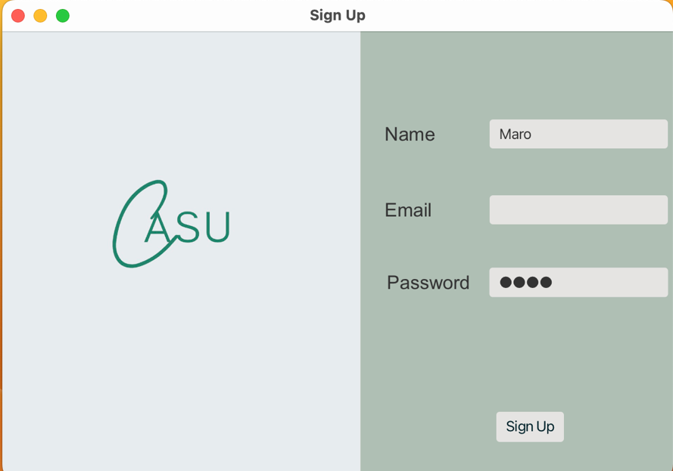

<Sign Up Page, Empty Password, Invalid Sign Up Page, Back, Sign Up page>

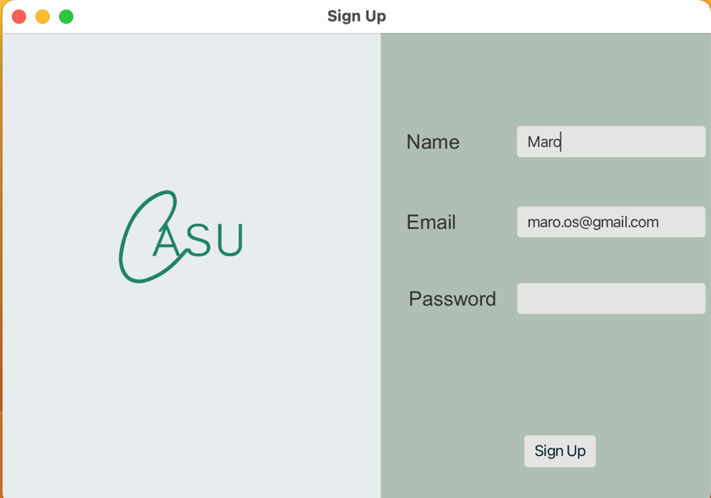

<Feed Page, Create Post, Create Post Page, Valid Text, Feed Page>

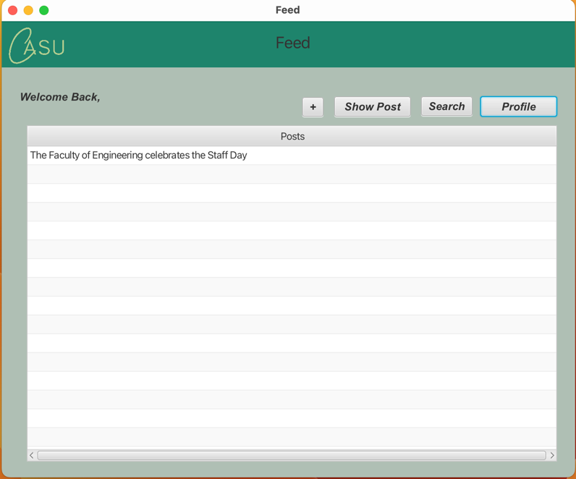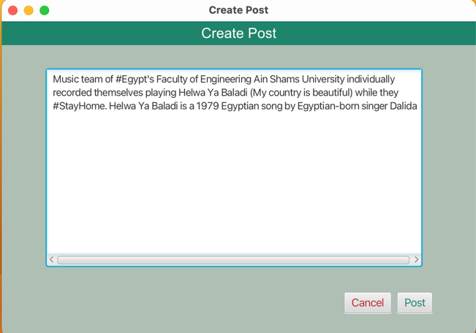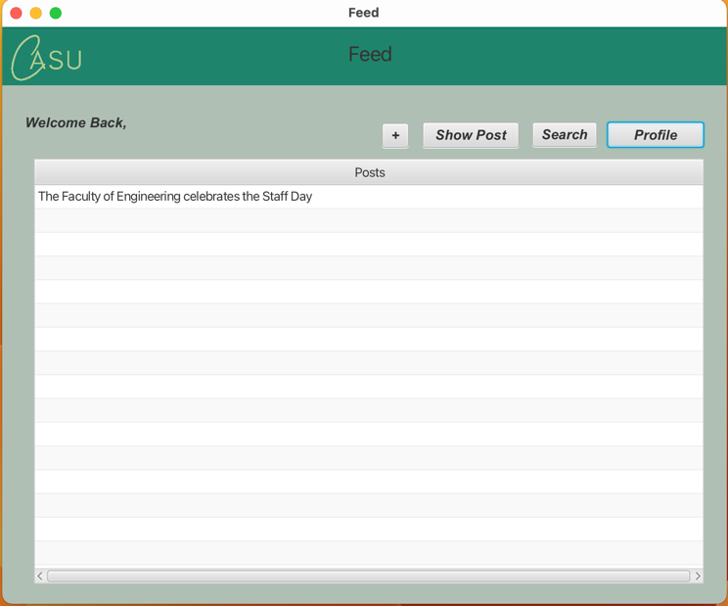

<Feed Page, Create Post, Create Post Page, Empty Text, Invalid Post Page, Back, Feed Page>

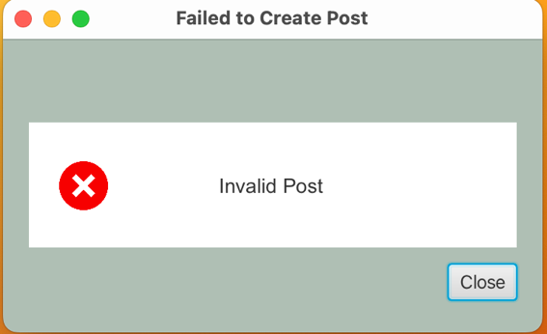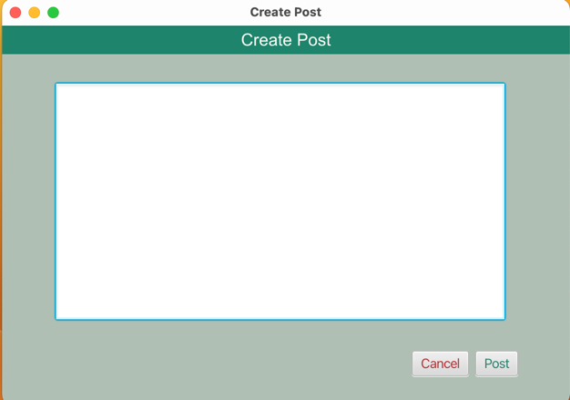

<Feed Page, Show Post, Post Page, Like, Back, Feed Page>

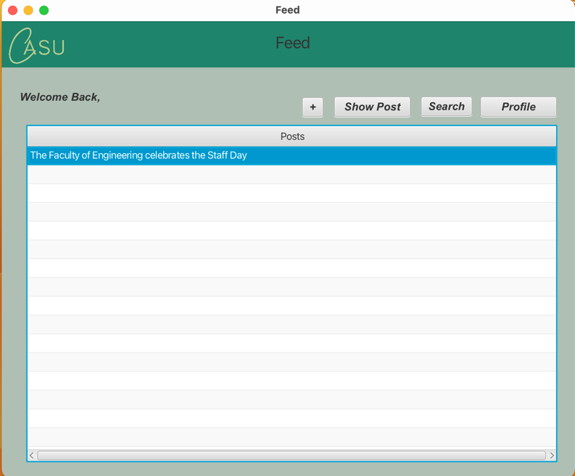

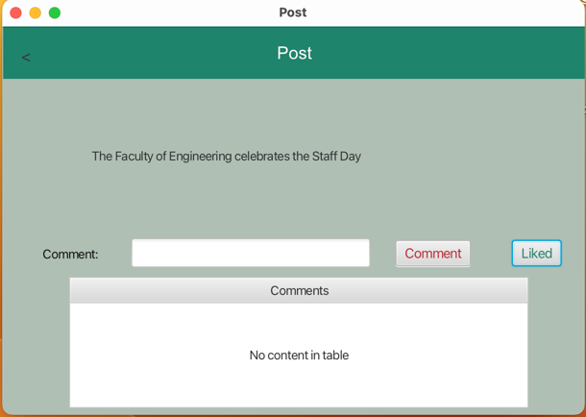

<Feed Page, Show Post, Post Page, Comment, Back, Feed Page>

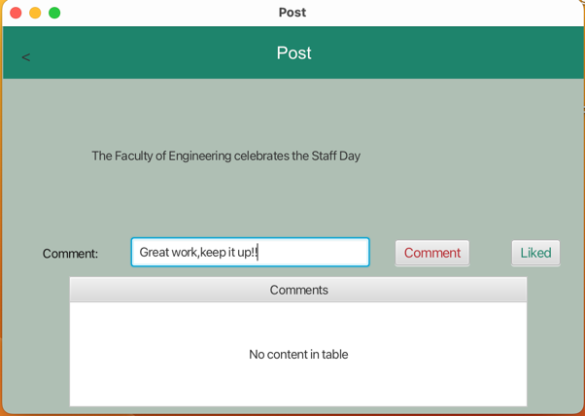

<Feed Page, Show Post, Post Page, Back, Feed Page>



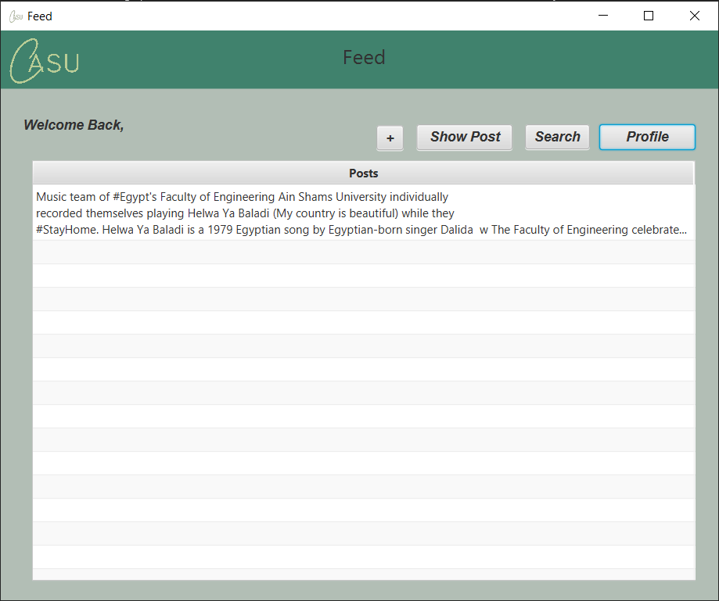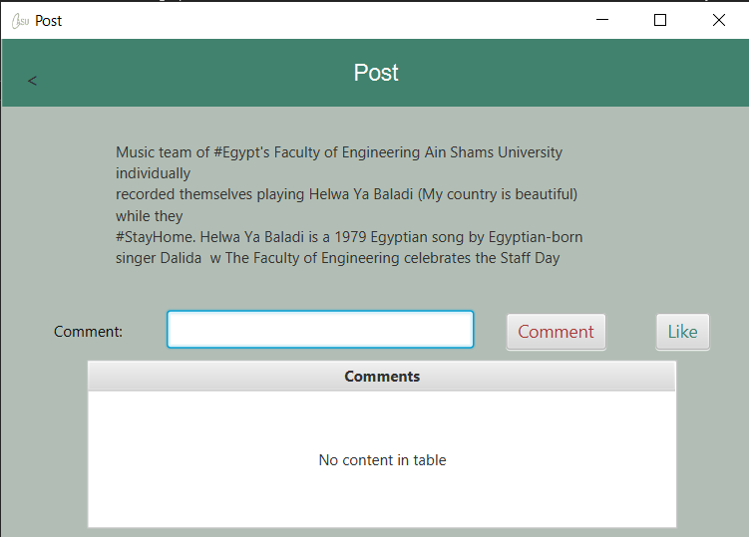

<Feed Page, Profile, User Profile Page, Back, Feed Page>

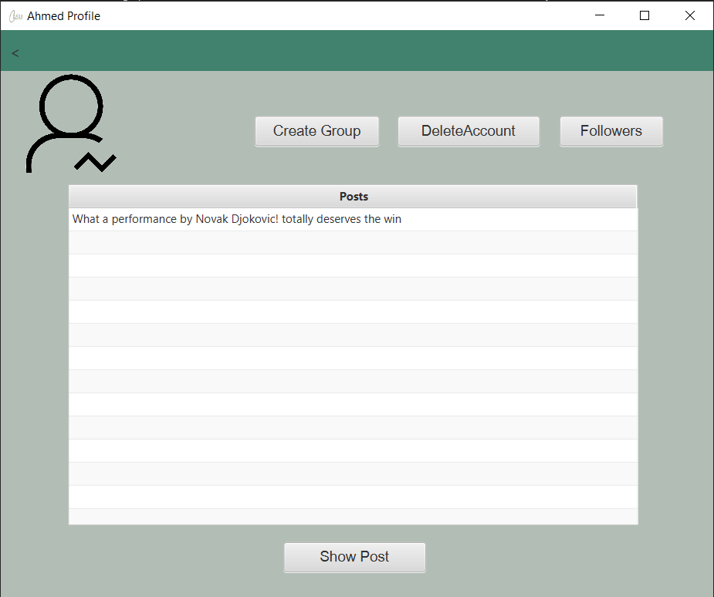

<Feed page, Search, Search Page, Show User, Profile Page, Back, Feed Page>

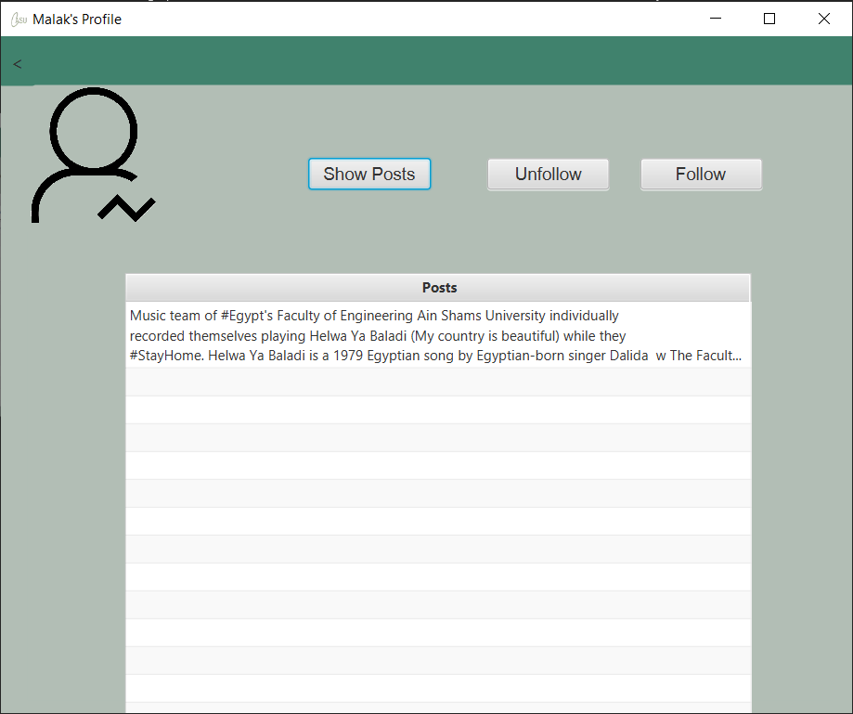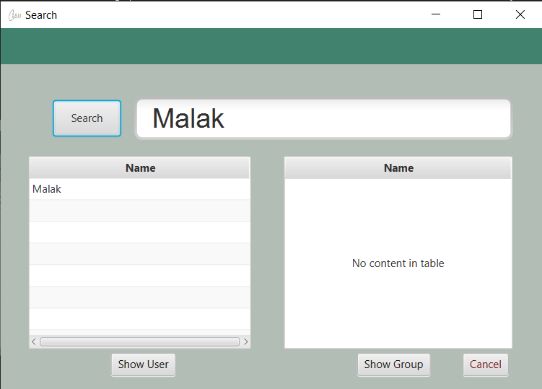

<Feed page, Search, Search Page, Show Group, Group Feed Page, Back, Feed Page>

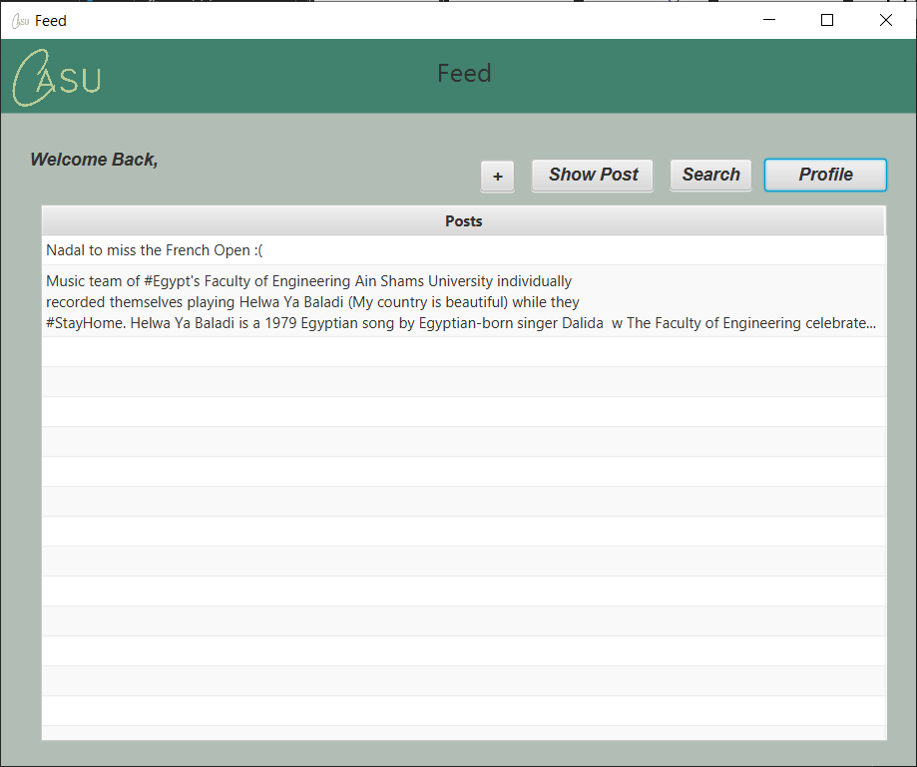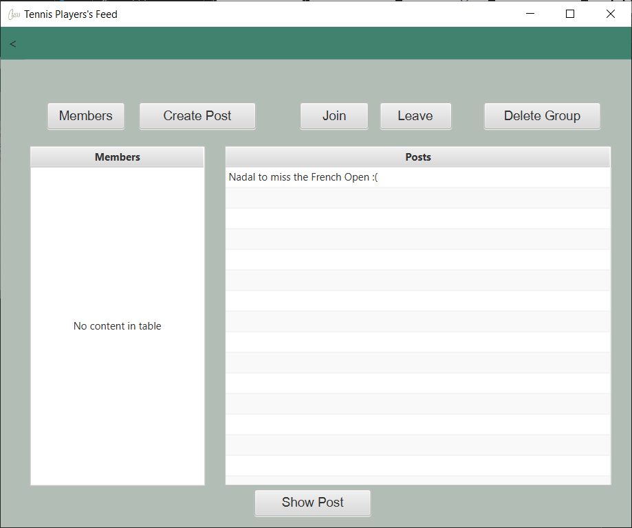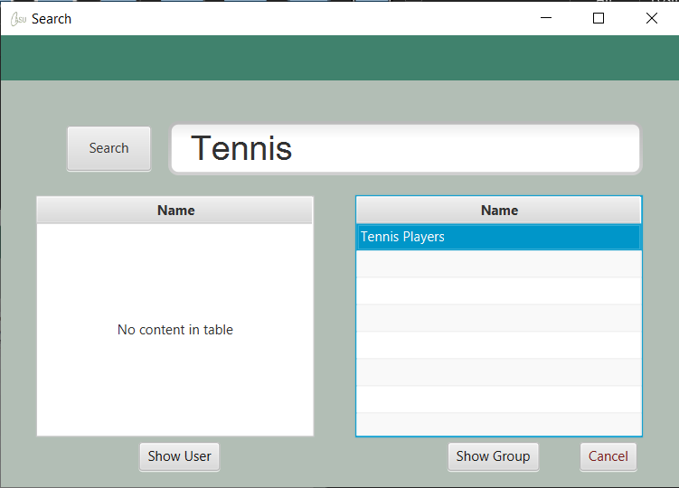

<User Profile Page, Create Group, Create Group Page, Valid Name, Feed Page>

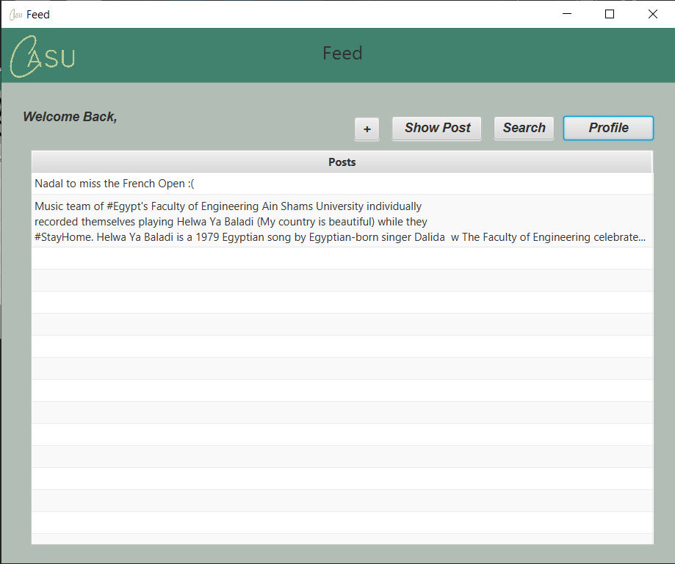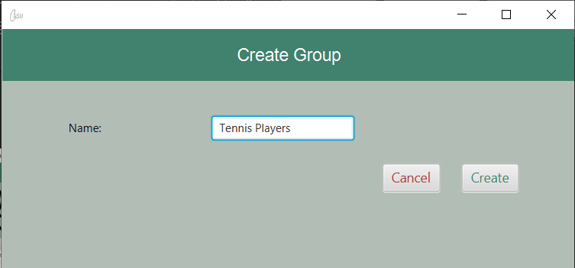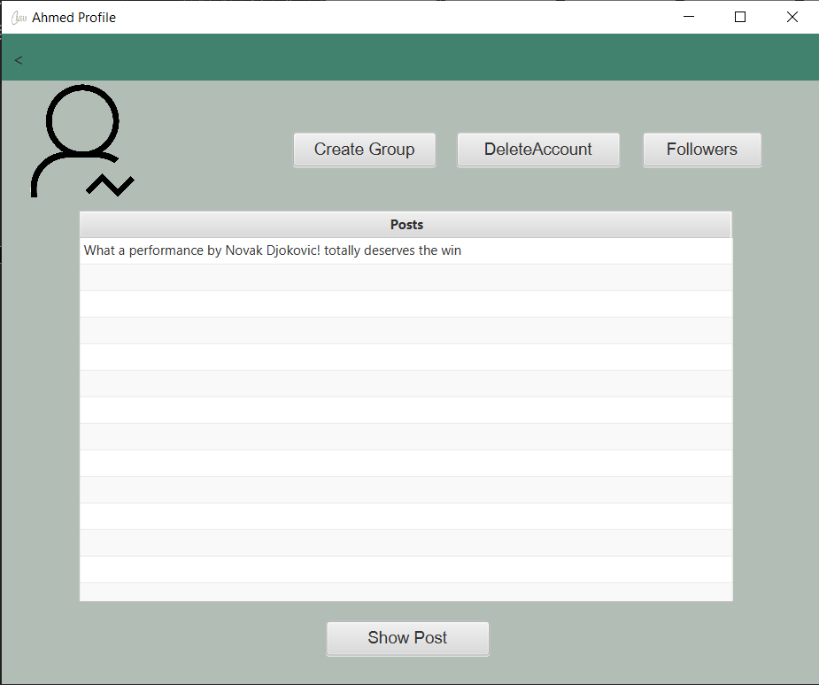

<User profile Page, Create Group, Create Group Page, Empty Name, Invalid Group Name Page, Back, Create Group Page, Valid Name, Feed Page>



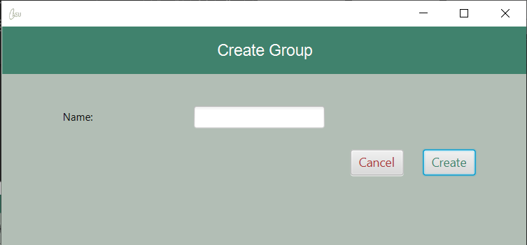

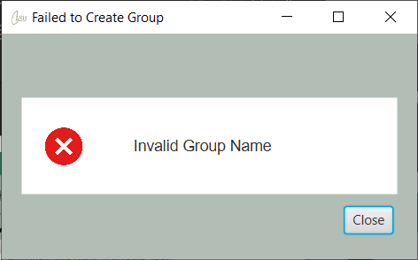

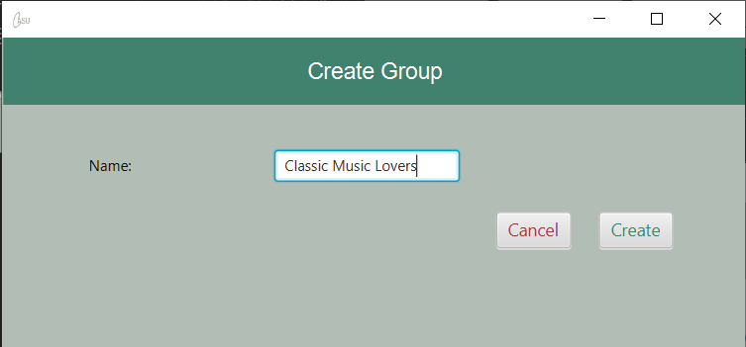



<User Profile Page, Followers, Followers Page, Back, User Profile Page>

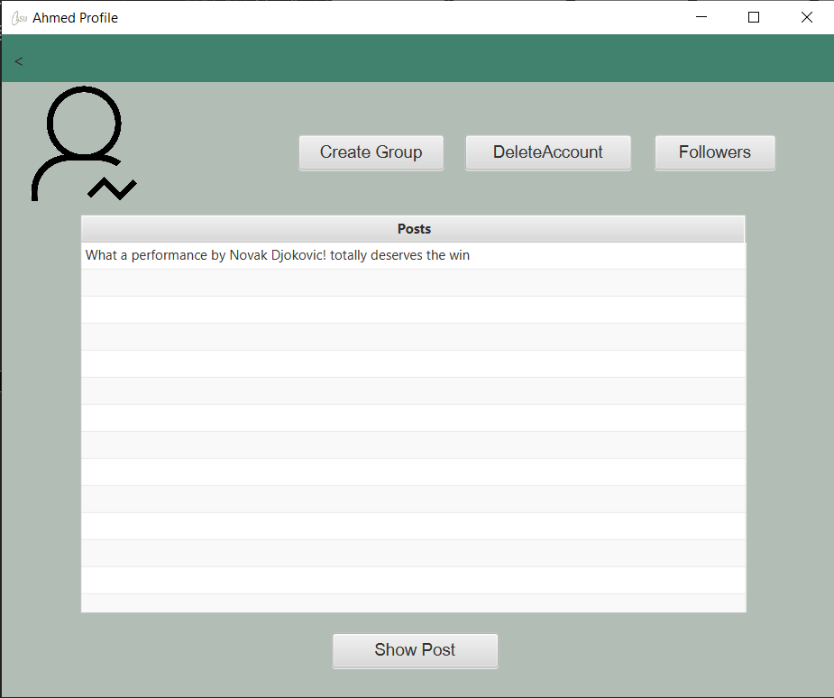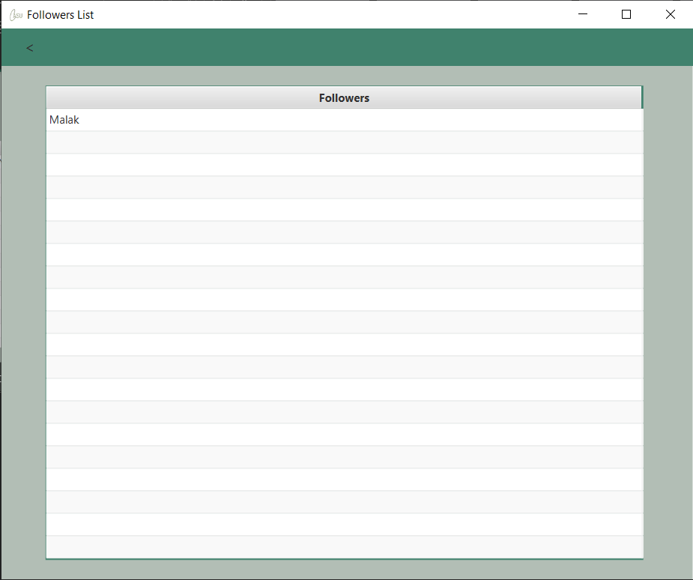

<User Profile Page, Show Post, Post Page, Back>

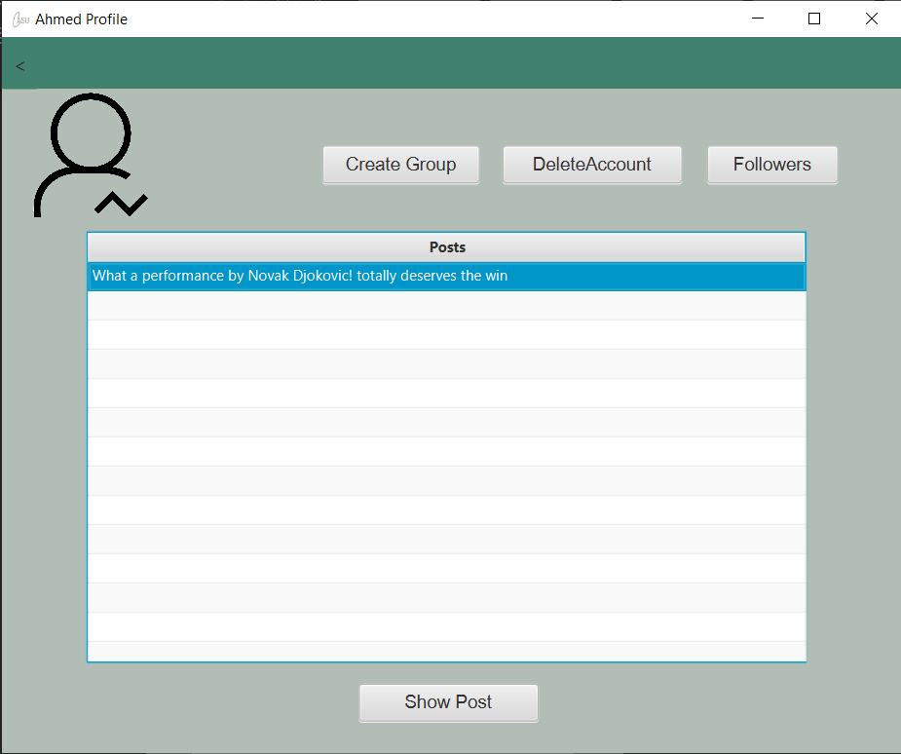

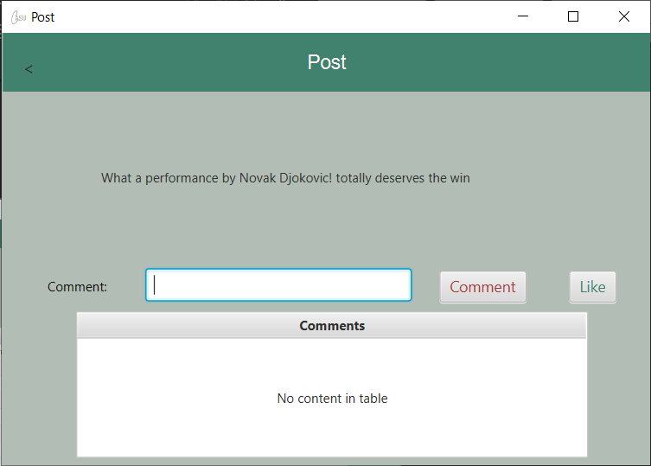

<User Profile Page, Show Post, Like, Back, User Profile Page>

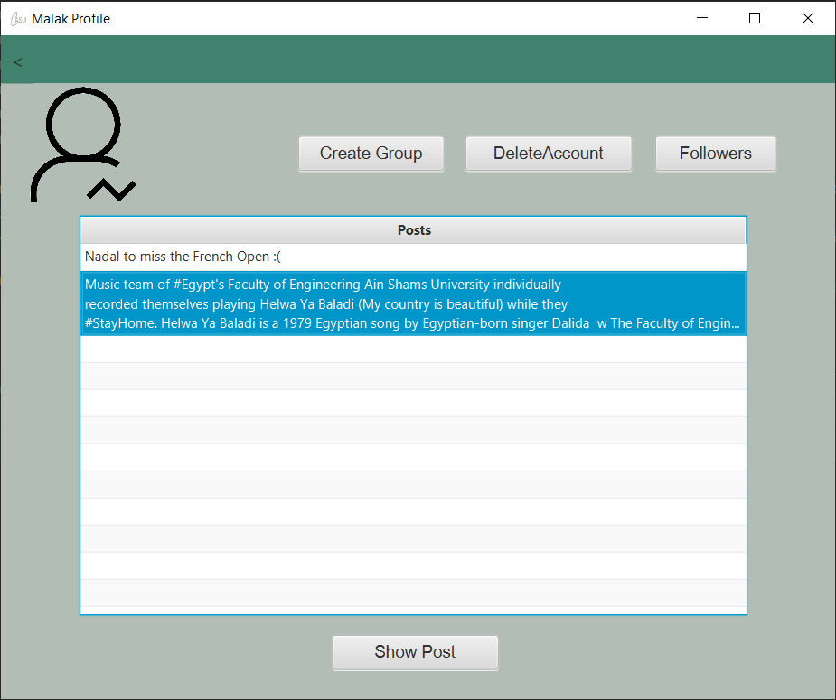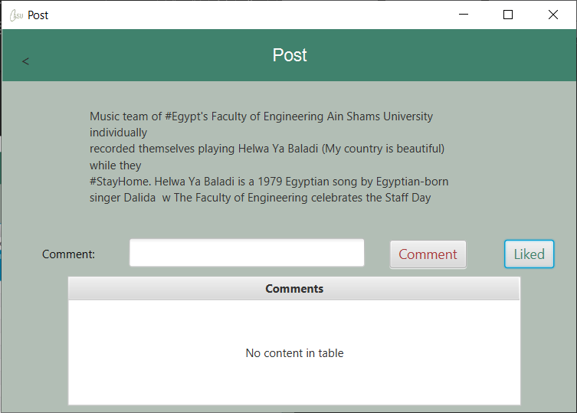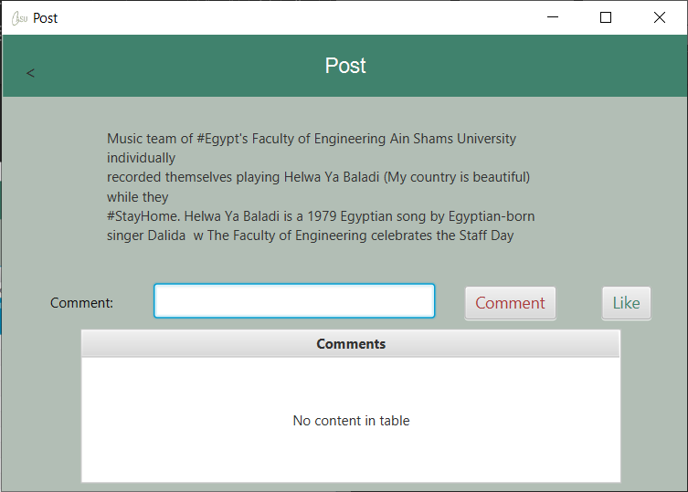

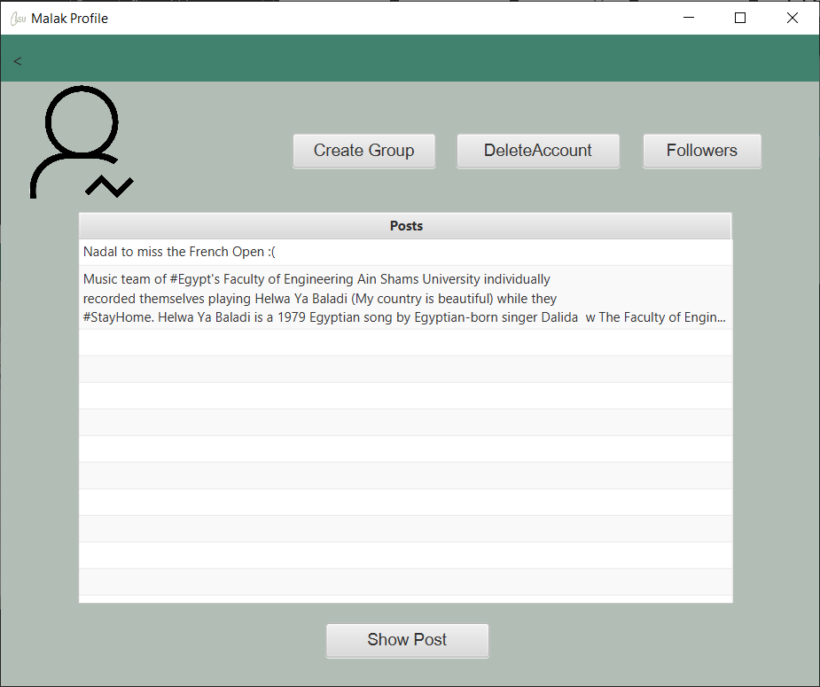

<User Profile Page, Show Post, Post Page, Comment, Back, User Profile Page>

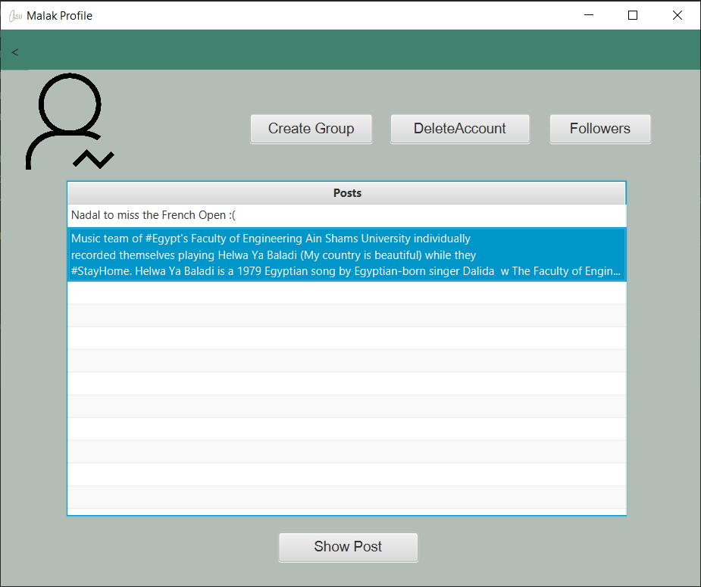

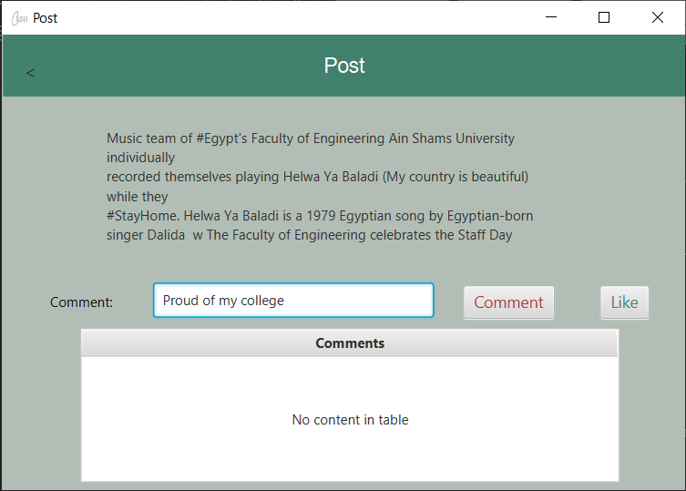

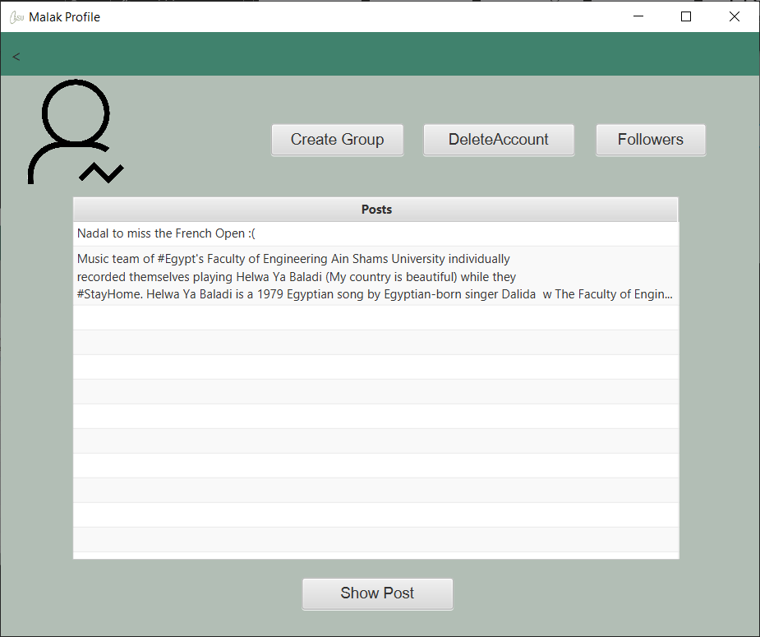

<User Profile Page, Delete Account, Delete Confirmation Page, Delete>

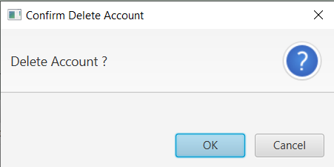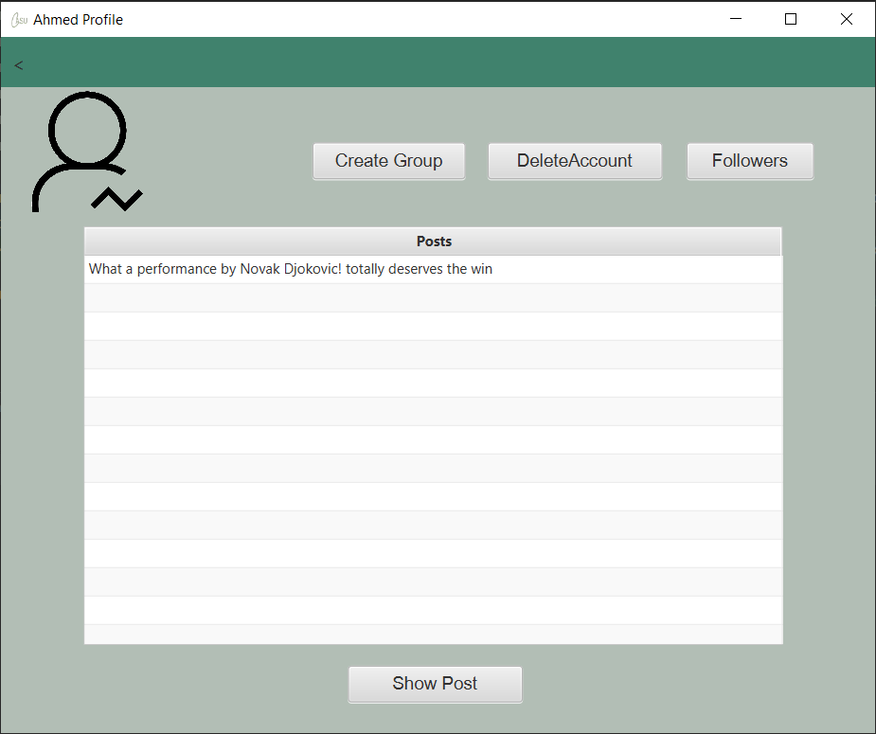

<User Profile Page, Delete Account, Delete Confrimation Page, Back, User Profile Page>

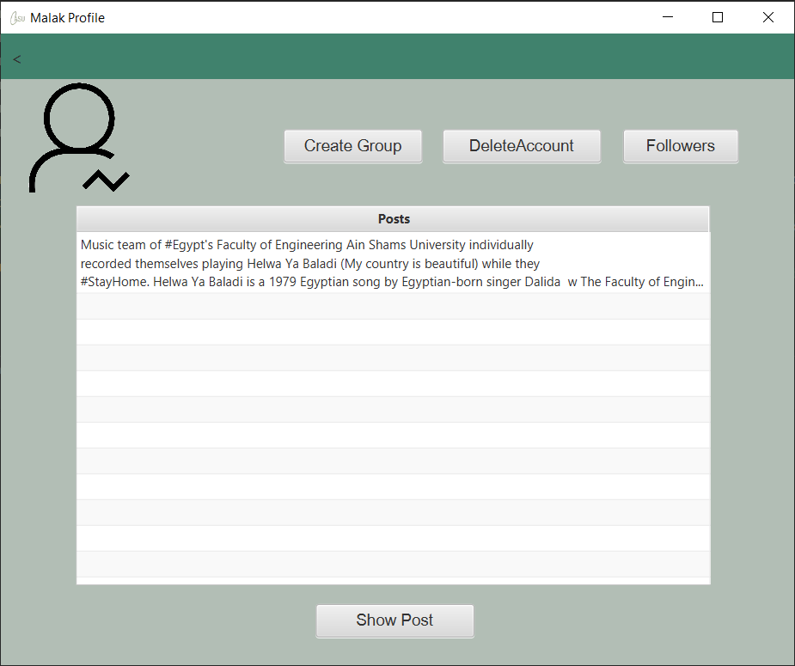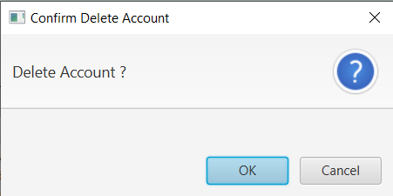

<Profile Page, Successful Follow, Profile Page>

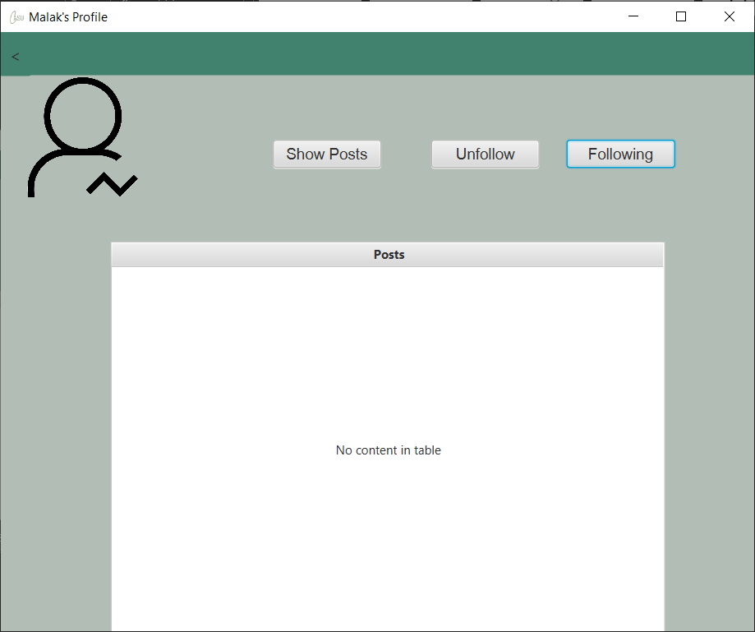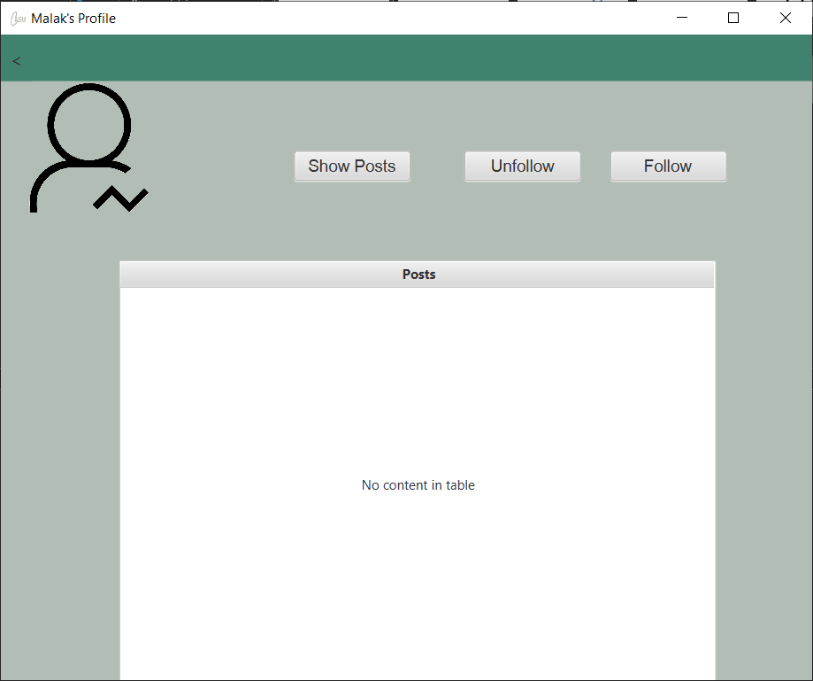

<Profile, Page, Successful Unfollow, Profile Page>

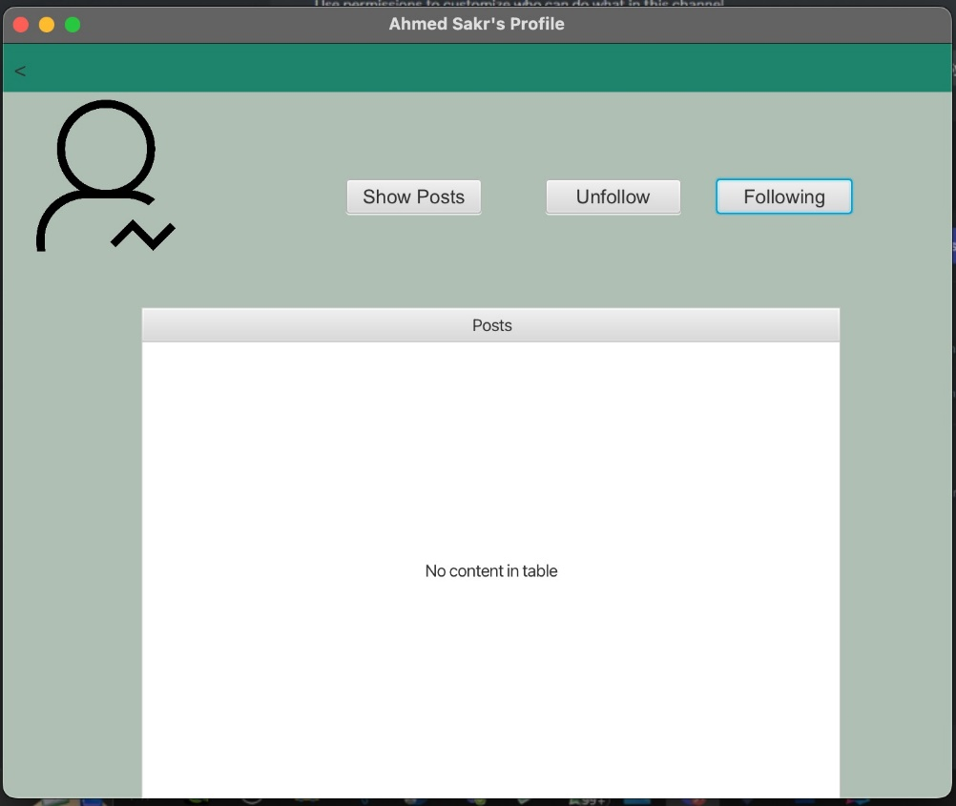

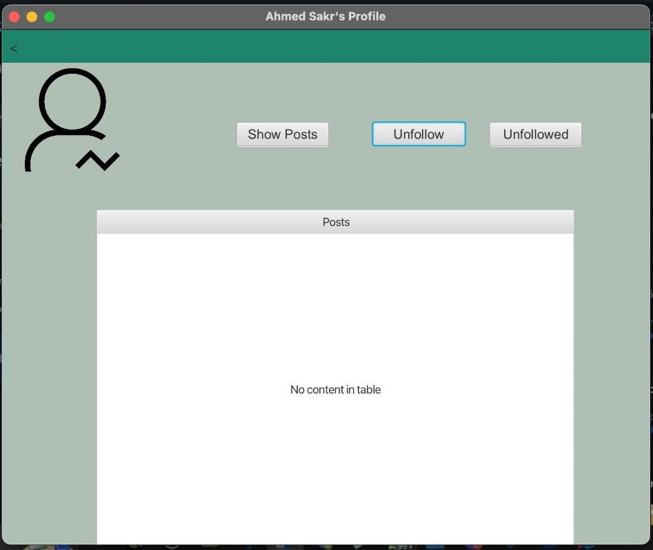

<Profile Page, Unsuccessful Follow, Follow Request Denied Page, Back, Search Page>

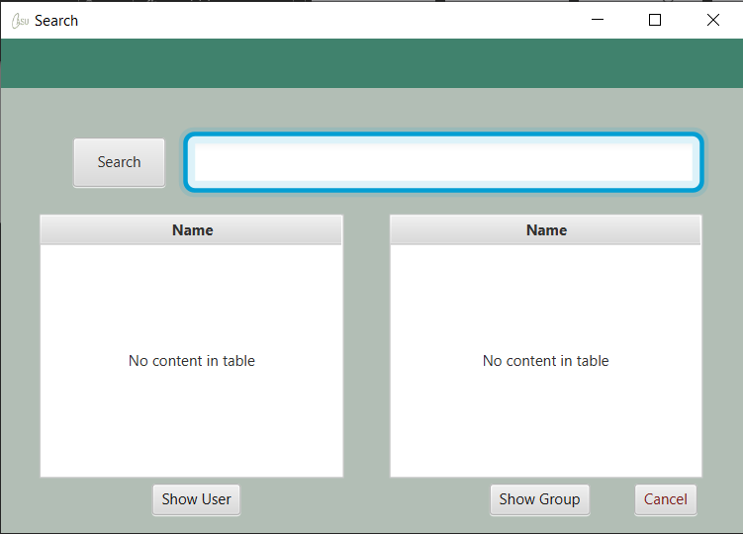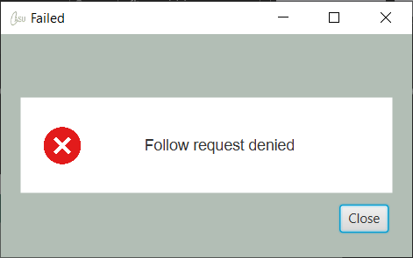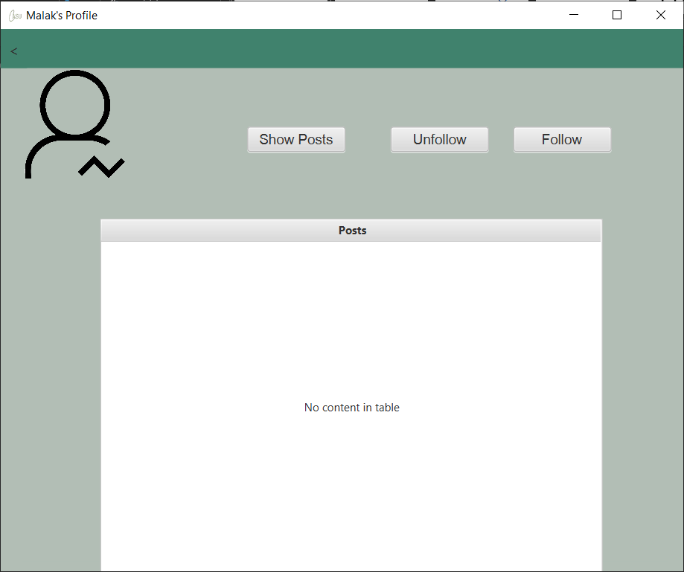

<Profile Page, Show Posts, Profile Page>



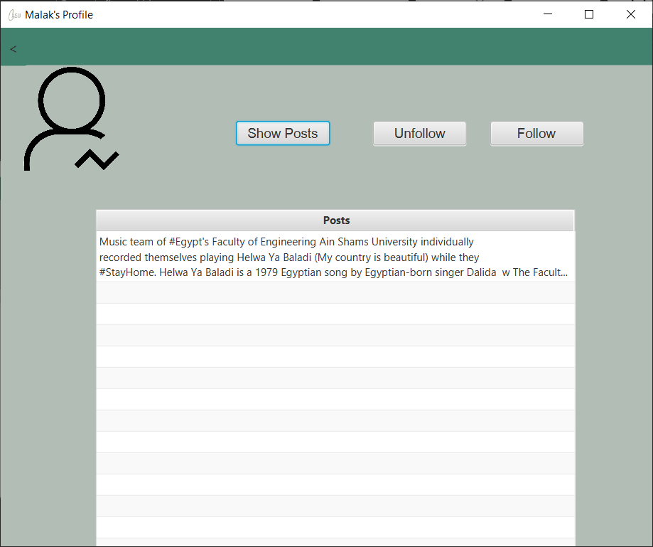

<Group Feed Page, Successful Join, Group Feed Page>

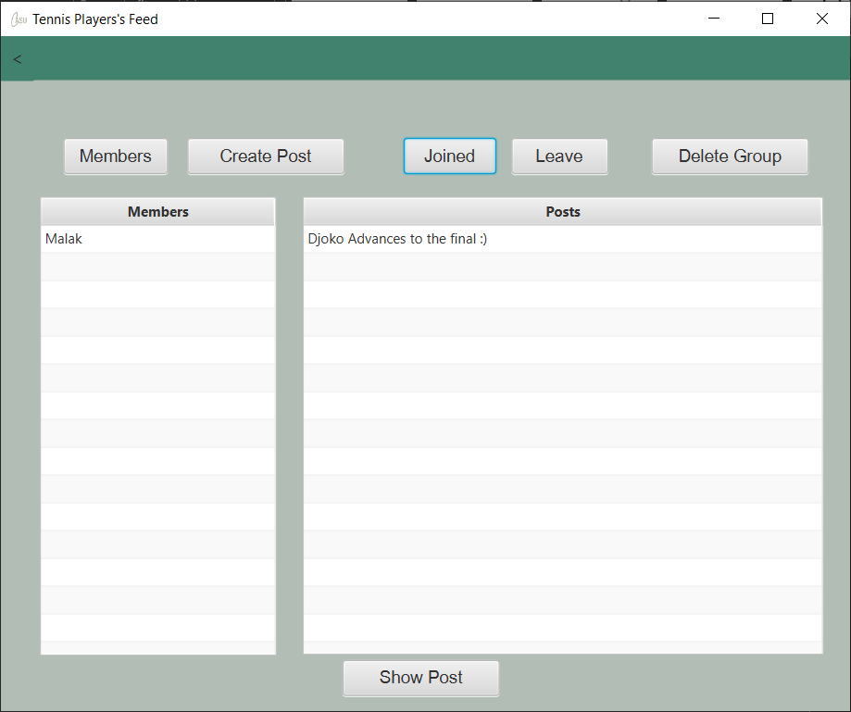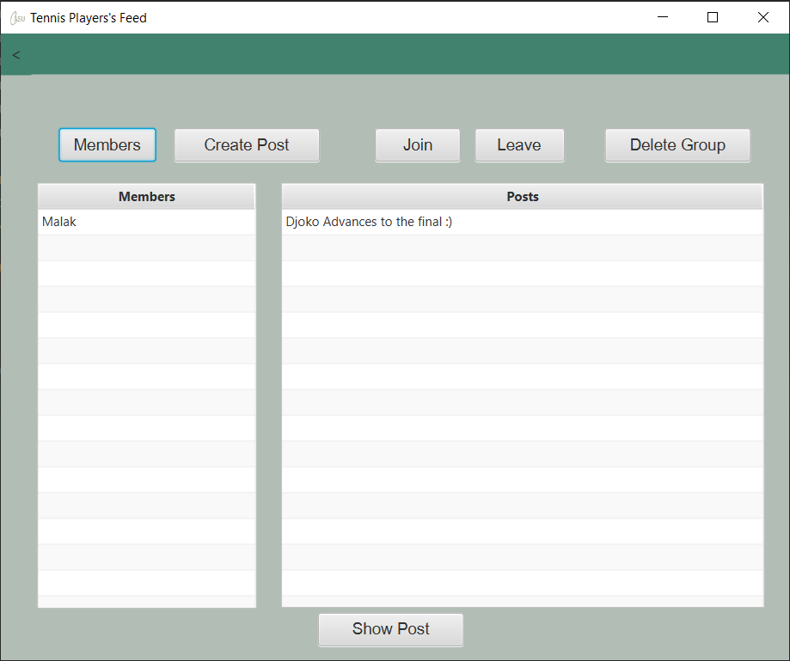

<Group Feed Page, Successful Leave, Group Feed Page>

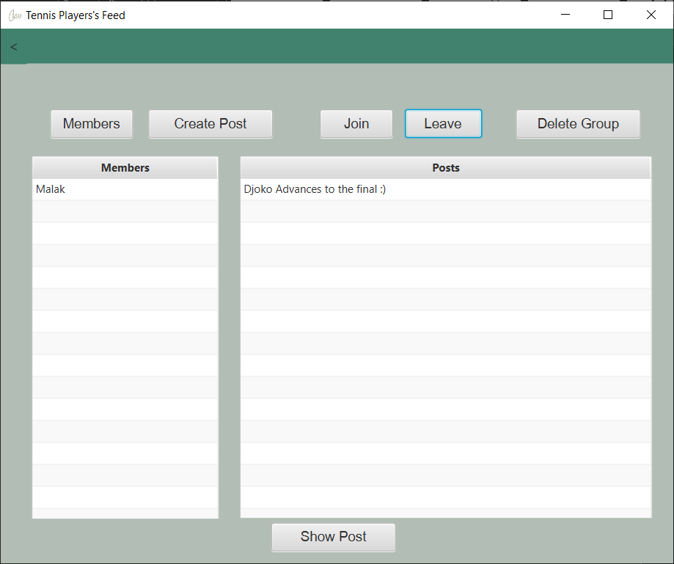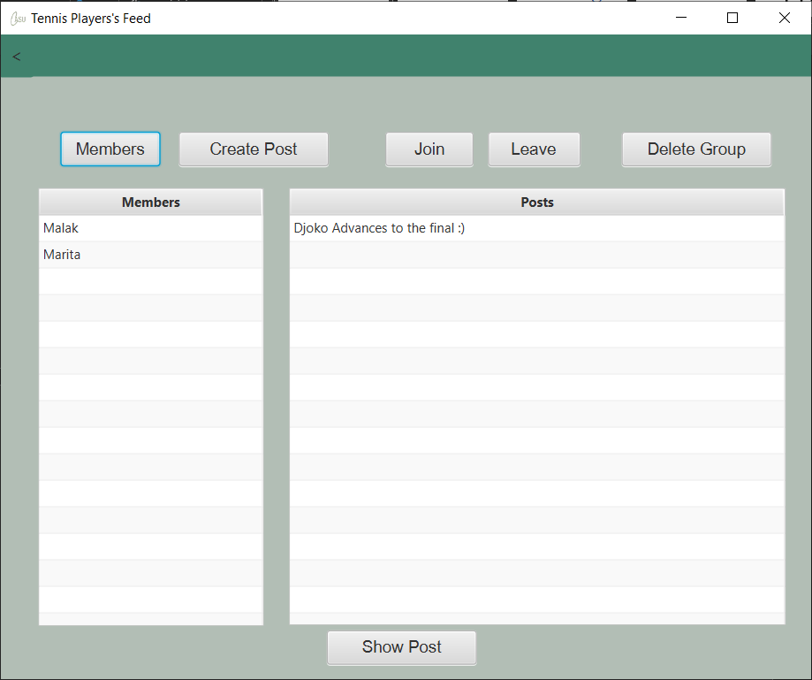

<Group Feed Page, Show Post, Posts Page, Back, Group Feed Page>

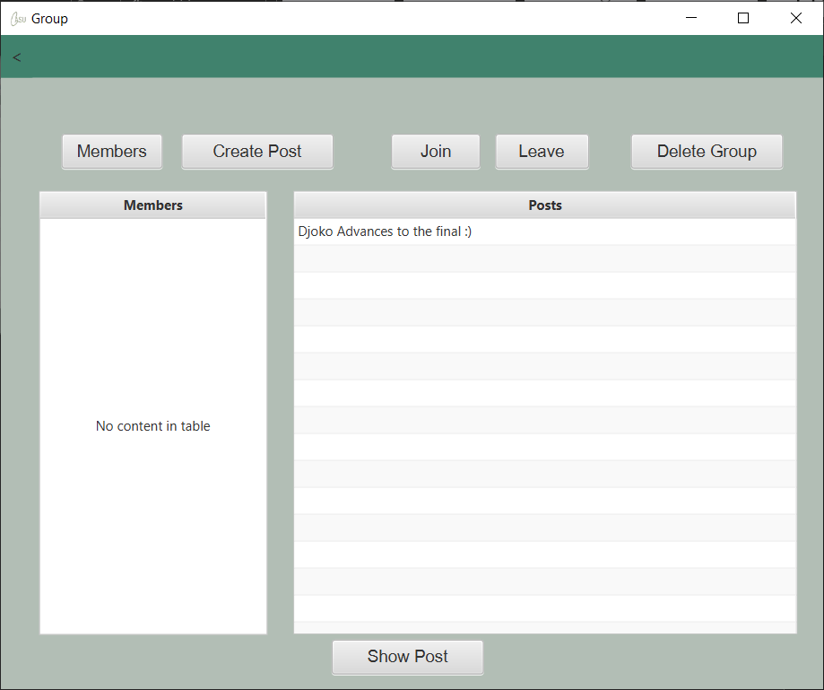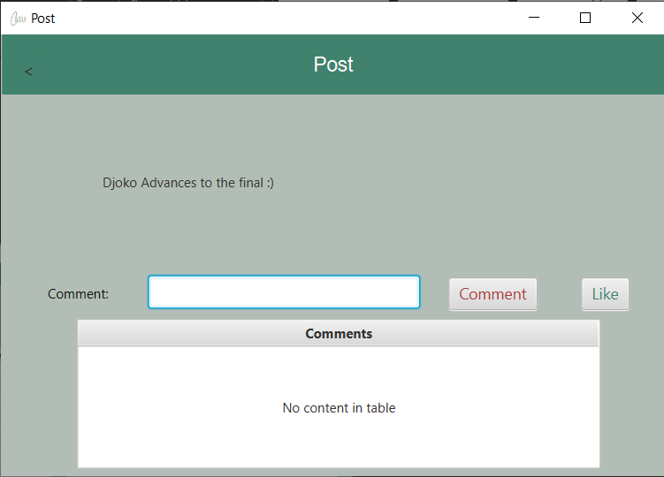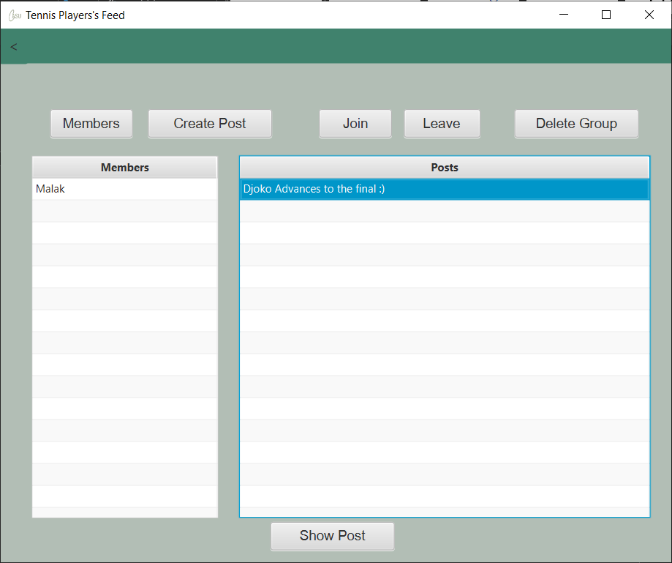

<Group Feed Page, Show Post, Posts Page, Like, Back, Group Feed Page>

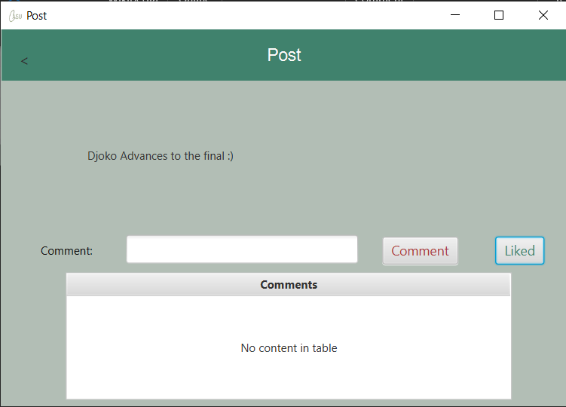

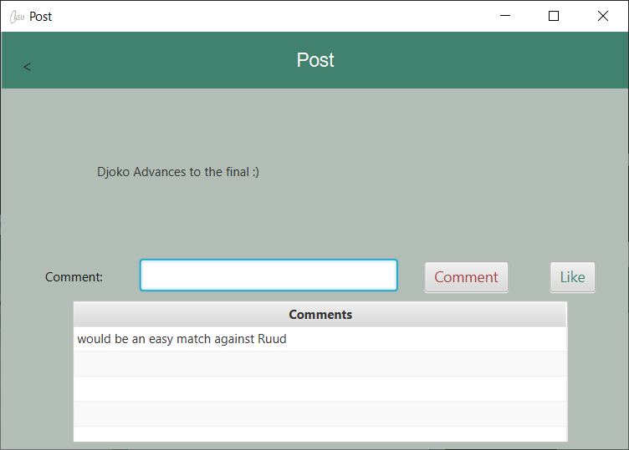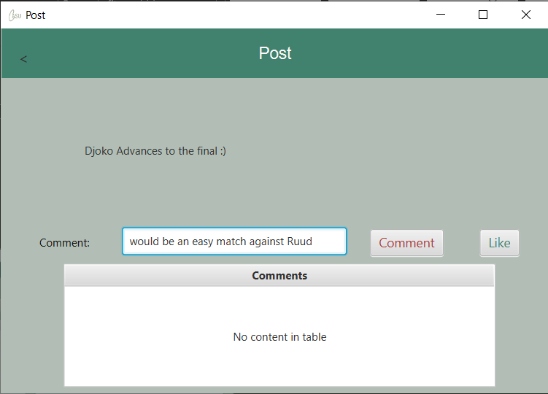<Group Feed Page, Show Post, Posts Page, Comment, Back, Group Feed Page

<Group Feed Page, Create Post, Create Group Post Page, Valid Text, Group Feed Page>



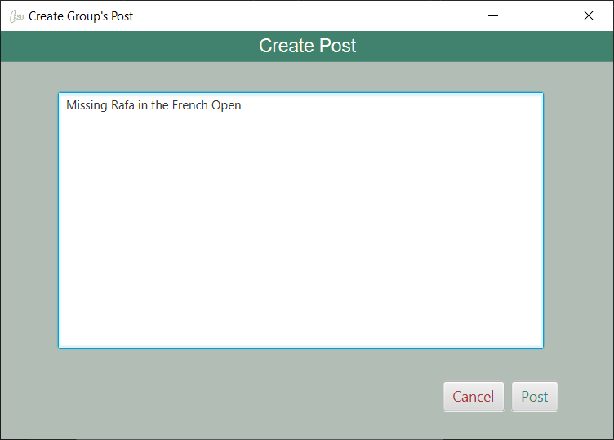

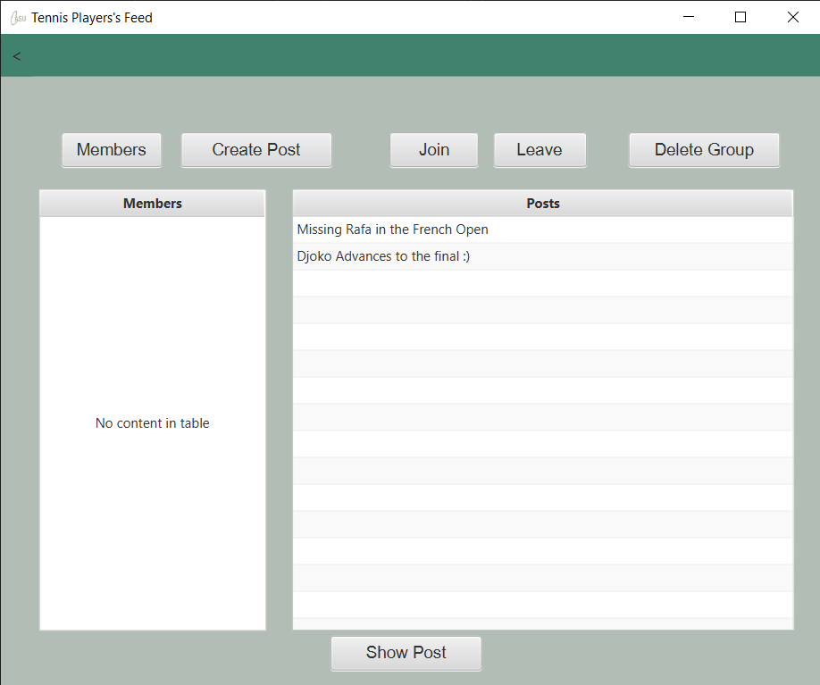

<Group Feed Page, Create Post, Create Group Post Page, Cancel, Group Feed Page>



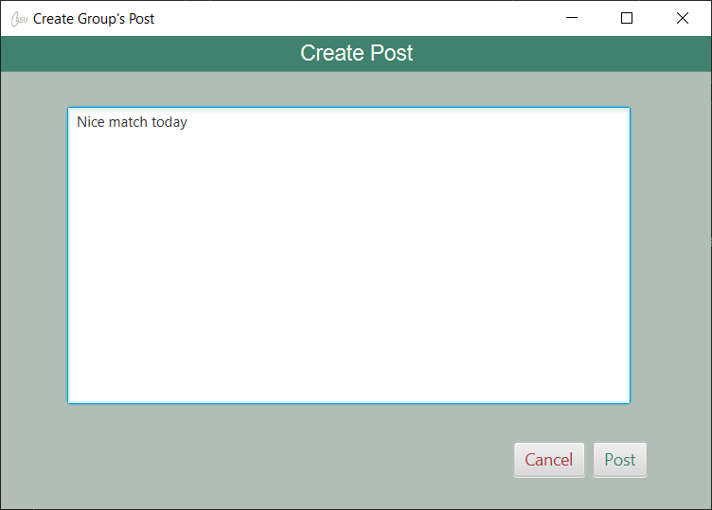



<Group Feed Page, Create Post, Create Group Post Page, Empty Text, Invalid Post Page, Cancel, Feed Page>



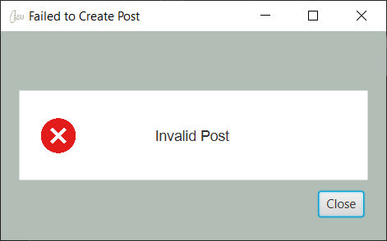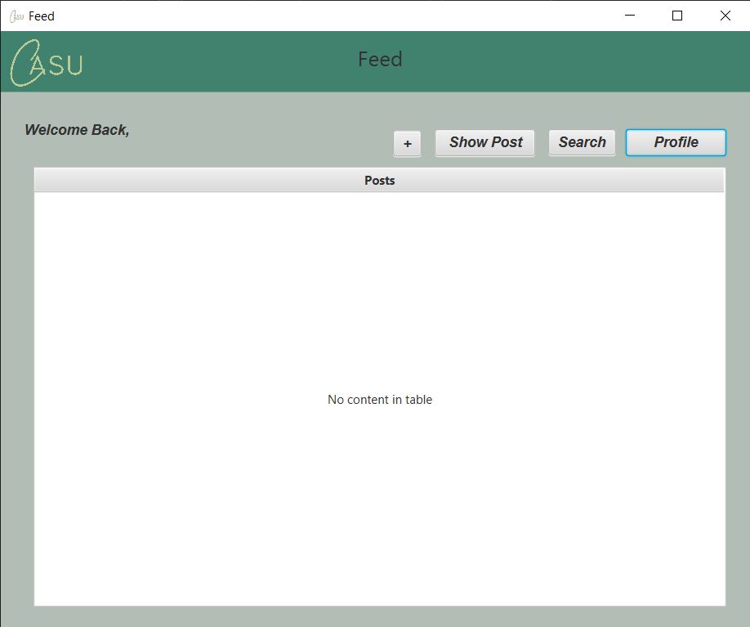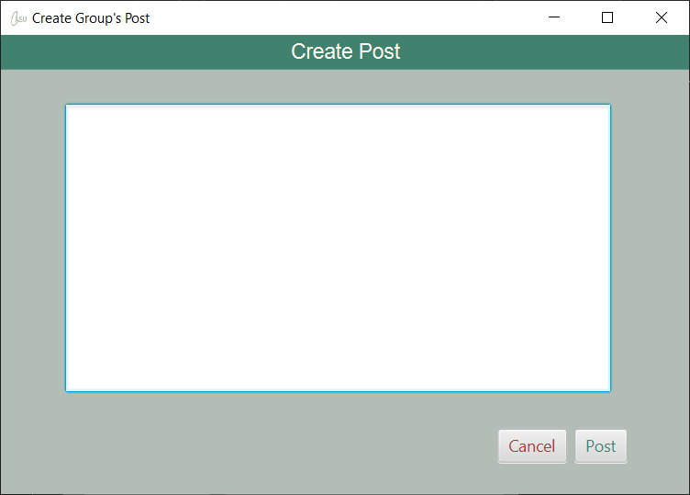

<Group Feed Page, Delete Group, Delete Confirmation Page, Confirm, Feed Page>

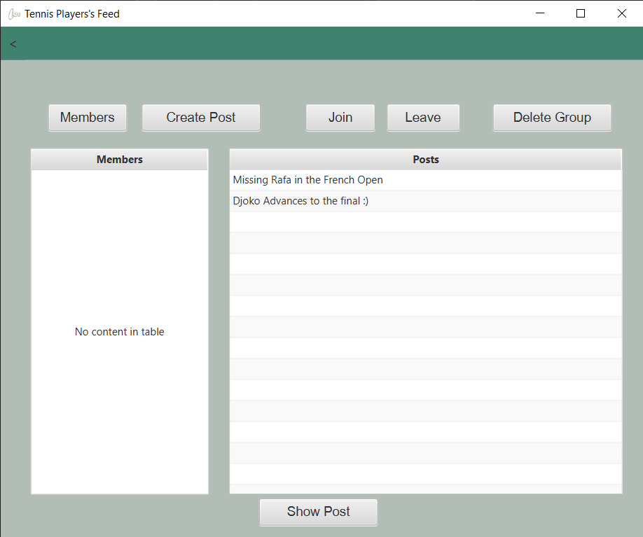

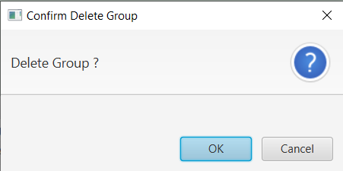



<Group Feed Page, Delete Group, Delete Confirmation Page, Cancel, Group Feed Page>